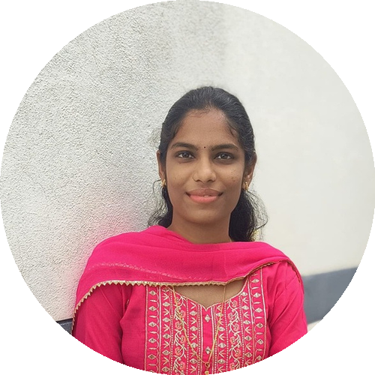 | SHARMI S  9524216365 | sharmisubramaniyan27@gmail.com | linkedin.com/in/sharmisubramaniyan

CAREER OBJECTIVE
To secure a challenging position in the biomedical field where I can apply my technical knowledge, enhance my skills, and contribute to organizational growth while continuously learning new technologies.
EDUCATION
Bachelor of Engineering – Biomedical Engineering
Kongunadu College of Engineering and Technology
CGPA: 8.03
Higher Secondary Education (HSC)
Government Girls Higher Secondary School, Tamil Nadu
Percentage: 65%
Secondary School Leaving Certificate (SSLC)
Government Girls Higher Secondary School, Tamil Nadu
Percentage: 100%
TECHNICAL SKILLS
- Biomedical Equipment Servicing & Maintenance
- Java Programming
- Medical Coding
PROJECTS
Non-Invasive Dehydration Detection
- Developed a system to monitor dehydration levels without the need for blood sampling.
- Focused on providing quick, safe, and patient-friendly hydration assessment.
Non-Invasive Wound Infection Detector
- Designed a device to detect wound infection using non-invasive sensing techniques.
- Aimed to enable early infection identification and support timely treatment.
INTERNSHIPS
Newton Biomedical Services, Karur — 15 Days
- Gained practical exposure to biomedical equipment servicing, maintenance, and troubleshooting procedures.
Galwin Technology, Trichy — 15 Days
- Learned basic medical device technologies and their applications in healthcare environments.
Hospital Training – ABC Hospital, Trichy — 15 Days
- Observed hospital engineering operations and medical equipment handling in a clinical setting.
CERTIFICATIONS
- NPTEL Certifications – Successfully completed NPTEL online courses and certification programs, gaining additional knowledge in engineering and technical domains.
VALUE ADDED COURSES
- LeetCode – Problem Solving
- Biomedical Hardware Training
- Medical coding
- MATLAB – Modeling and Simulink
SKILLS
Communication Skills • Teamwork • Adaptability

